Black Power

By 1965, the Civil Rights Movement had won broad legislation affirming the rights of black citizens. After the passage of the 1964 Civil Rights Act and the 1965 Voting Rights Act, the federal government took a much greater role in monitoring school integration, registering black voters and prosecuting racially motivated crimes.

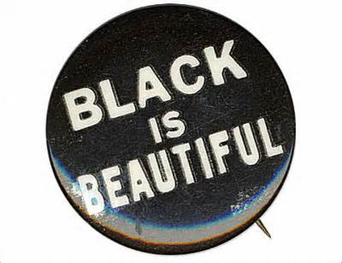
Blacks had forced the federal government to recognize its responsibilities. They had established their own political strengths. They had seen the rise of new and powerful black leaders. They had witnessed the structures of segregation dismantled by the courageous acts of ordinary people like themselves. The black militant or ‘Black Power’ movement gave black people throughout America a renewed pride. This led to a revival of all things ‘African’ where black women would wear their hair naturally (became known as the afro), men would wear traditional African garb like the dashiki, and African traditional music influence popular music from blues to the development of hip hop. They argued that they shouldn’t have to adopt white culture to fit in but rather argued that their culture should be valued through the moniker “black is beautiful.”

Yet the exhilarating successes of the movement were accompanied by tensions within its ranks. Some of the younger civil rights activists criticized Martin Luther King Jr. for devoting resources to mass marches instead of grassroots political organizing. Some questioned the doctrine of nonviolence. Black power militants objected to the role played by Whites in the movement and said Blacks should not rely on Whites but instead build their own independent political structures.

The Vietnam War raised another point of contention. Some civil rights activists argued that the war drained national resources from the struggle against poverty and injustice at home; others thought civil rights and foreign policy should remain separate. More militant activists became increasingly frustrated with the slow pace of change. The students in SNCC asked Whites to leave and chose black militant Stokely Carmichael as their leader. They took up the phrase “Black Power” to describe their new focus on building black led-political organizations in the South.

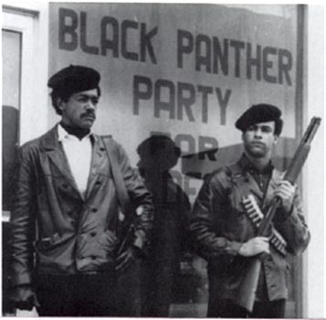
The Nation of Islam, advocating black separatism where blacks segregated themselves intentionally and developed black neighborhoods, grew under the leadership of Elijah Muhammad. Its most popular spokesman, Malcolm X, criticized the strategy of nonviolence, saying “it is criminal to teach a man not to defend himself when he is the constant victim of brutal attacks.” Malcom X argued that blacks should have a right to defend themselves and was a strong proponent of 2nd Amendment rights.

The message of black militancy struck a chord for many inner-city youth whose lives were not affected by the successes of the Civil Rights Movement. They lived in the midst of crime and poverty, they attended inadequate schools and dropped out early, and they had little chance to get decent jobs. New civil rights laws could not change the fact that their own futures were dim.

Frustrated by a movement that seemed to be passing them by, many young Blacks took their fury to the streets. Cities erupted all across America during four consecutive summers. In 1964, black areas of New York City, Chicago, and Philadelphia were torn by rioting. The next summer, the worst riot in decades destroyed the Watts section of Los Angeles—leaving 34 people dead, 5,000 under arrest and millions of dollars of property burned. The rioting continued through the summer of 1967. By the time it was over, more than 17,000 people had been arrested, nearly 100 were dead, and more than 4,000 injured.

