On February 1, 1960, four African-American students of North Carolina Agricultural and Technical State University sat at a white-only lunch counter inside a Greensboro, North Carolina Woolworth’s store. While sit-ins had been held elsewhere in the United States, the Greensboro sit-in catalyzed a wave of nonviolent protest against private-sector segregation in the United States.
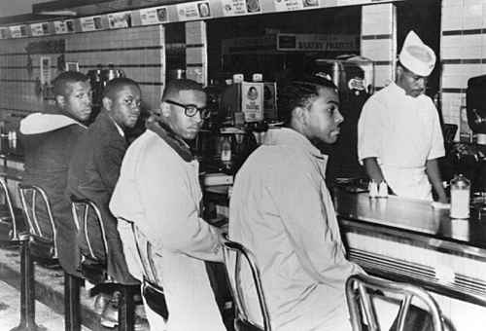
The first Greensboro sit-in was not spontaneous. The four students who staged the protest, all of them male freshmen, had read about nonviolent protest, and one of them, Ezell Blair, had seen a documentary on the life of Mohandas Gandhi. Another of the four, Joseph McNeil, worked part-time in the university library with Eula Hudgens, an alumna of the school who had participated in freedom rides; McNeil and Hudgens regularly discussed nonviolent protest. All four of the students befriended white businessman, philanthropist, and social activist Ralph Johns, a benefactor of both the NAACP and North Carolina Agricultural and Technical.

The first sit-in was meticulously planned and executed. While all four students had considered different means of nonviolent protest, McNeil suggested the tactic of the sit-in to the other three. To him, discipline in executing the protest was paramount. Months before the sit-in, he attended a concert at which other African-American students behaved tactlessly, leaving him determined not to repeat their error. The plan for the protest was simple. The students would first stop at Ralph Johns’ store so that Johns could contact a newspaper reporter. They would then go to the Woolworth’s five-and-dime store to purchase items, saving their receipts. After finishing their shopping, they would sit down at the whites’ only section of the lunch counter and courteously request service, and they would wait until service was provided.

The protest occurred as planned on Monday, February 1, 1960. Despite urbanely requesting service, the students were refused it, and the manager of the Woolworth’s store requested that they leave the premises. After leaving the store, the students told campus leaders at Agricultural and Technical what had happened.

The next morning twenty-nine neatly dressed male and female North Carolina Agricultural and Technical students sat at the Woolworth’s lunch counter. The protest grew the following day, and on Thursday, white students from a nearby women’s college took part in the protests, which expanded to other stores. Soon crowds of students were mobbing local lunch counters. As the protests grew, opposition grew vociferous. Crowds of white men began appearing at lunch counters to harass the protesters, often by spitting, uttering abusive language, and throwing eggs. In one case, a protester’s coat was set on fire, and the assailant was arrested.

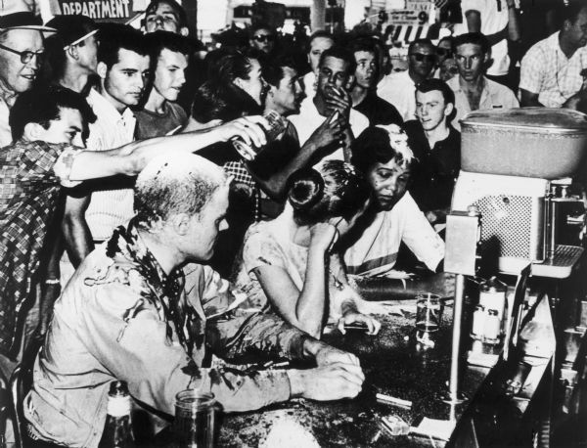
The protests continued each day that week. On Saturday, fourteen hundred students arrived at the Greensboro Woolworth’s store. Those who could not sit at the lunch counter formed picket lines outside the store. A phoned-in bomb threat cut the protest short, but the following week sit-ins began at Woolworth’s stores in Charlotte, Winston-Salem, and Durham. Soon other five-and-dime and department stores with segregated lunch counters became targets of these protests.

The reaction of police departments in the region was, by and large, muted. In the case of the Greensboro Woolworth’s sit-ins, protesters were left alone by the police department while those reactionaries who became violent were prosecuted. Statewide no protesters were arrested until forty-one black students in a picket line at the Cameron Village Woolworth’s in Raleigh were charged with trespassing.

Despite these arrests, progress was swift. At many stores, African-Americans were soon eating at the same lunch counters as whites. For instance, at the Greensboro S.H. Kress store, blacks and whites were eating together at the lunch counter by the end of February 1960. Some stores in Raleigh closed their lunch counters altogether to preclude protests. Though most stores did not immediately desegregate their lunch counters, the sit-ins were successful both in forcing partial integration and in increasing national awareness of the indignities suffered by African-Americans in the southern United States.
The 1960 sit-ins began without the assistance of any organization, and they effected partial desegregation in less than a month without legal action. They proved one of the simplest and most efficacious protests of the civil rights movement.

